Name: Harshavarthini Annamalai Roll No: 240701181

EXPERIMENT 5

Dashboard Creation in Zoho Creator

Aim

To design and implement a Dashboard in Zoho Creator for visualizing and managing application data using various widgets, charts, and reports, and to understand the process of building an interactive dashboard for a business application.

Introduction
A Dashboard in Zoho Creator is a visual interface that provides a consolidated view of key metrics and data points from an application. It allows users to monitor important information at a glance using widgets, charts, graphs, and quick links. Dashboards help in decision-making by presenting real-time data in an organized and visually appealing manner. Zoho Creator provides drag-and-drop dashboard components that can be configured to display data from various forms and reports. Dashboards can be customized with different chart types, summary widgets, and navigation links to create a comprehensive business overview.

Objectives of the Study
- To understand the concept and purpose of dashboards in Zoho Creator.
- To learn how to create and configure a dashboard using different widgets.
- To understand how to add charts, summary cards, and quick links to a dashboard.
- To explore the customization of dashboard layout and components.
- To develop a functional dashboard for a real-world use case.

Procedure
- Log in to the Zoho Creator platform.
- Open the existing application or create a new application for the required use case.
- Navigate to the Dashboard section and create a new dashboard.
- Add summary widgets to display key metrics such as total amounts, total orders, and total unit prices.
- Configure the widgets with appropriate data sources and aggregation functions.
- Add chart widgets such as bar charts, pie charts, and line charts to visualize data trends.
- Configure the charts with appropriate X-axis and Y-axis data fields.
- Add quick links to forms for easy data entry and navigation.
- Arrange and customize the dashboard layout for better visual presentation.
- Save and preview the dashboard to verify its appearance and functionality.
- Modify the dashboard components if any changes are required.
- Publish the application after completing the dashboard creation.

Illustrative Example
Consider a Food Delivery System in which order details, customer profiles, menu items, and restaurant branches are managed through a Zoho Creator application.

Implementation using Zoho Creator

Create a Dashboard for the Food Delivery System. Add summary widgets such as Total Total Amounts, Total Item Total, Total Unit Prices, and Total Total Orders. Add a Payment Method section displaying counts for Wallets, Cash, Cards, and Total. Add Quick Links for adding new Order Records, Order Line Items, Customer Profiles, and Menu Items. Add charts such as "Order Status by Total Amount" (bar chart) and "Loyalty Status by Total Orders" (bar chart). Store and display all data in real-time. Generate reports to view and manage order and customer information.

5.2 Illustrative Form Design

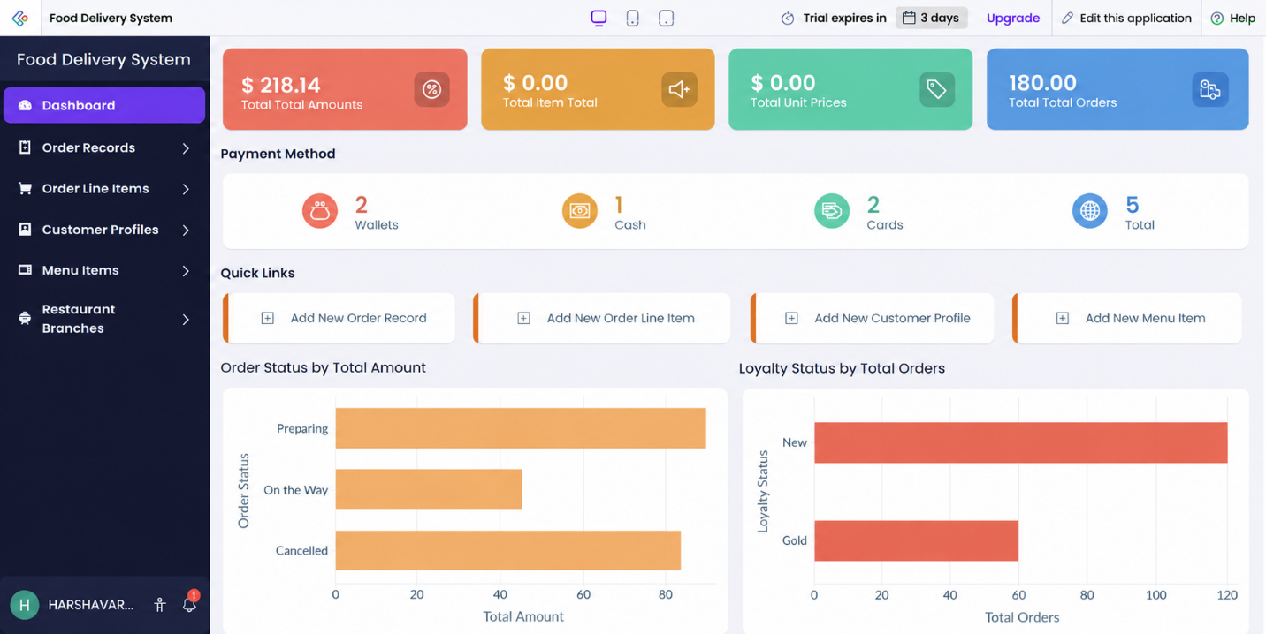

6. Advantages and Limitations
6.1 Advantages
    - Provides a consolidated view of key business metrics.
    - Visual representation of data improves understanding and decision-making.
    - Real-time data updates help in monitoring business performance.
    - Quick links enable easy navigation and data entry.
    - Dashboards can be customized easily with drag-and-drop components.
    - Reduces the need for manual report generation.

6.2 Limitations
    - Complex dashboard customization may require Deluge scripting.
    - Performance may be affected with large datasets.
    - Advanced chart types may require additional configuration.
    - Dashboards depend on the capabilities of the selected platform.
    - Large or highly specialized enterprise systems may need additional development.

7.Result
The experiment was completed successfully by studying dashboard creation and implementing an interactive dashboard in Zoho Creator. The exercise demonstrated how summary widgets, charts, quick links, and navigation components can be combined to create a comprehensive business dashboard with reduced coding effort..

